

# AUGUST- 2023

**Programme : B.E / B. Tech**

**Course Code : CSA1190**

**Course Name** **: OBJECT ORIENTED ANALYSIS AND DESIGN**

**Date : 28-08-2023**

OOAD PRATICAL DAY 3 Marks:20

**EXP 21 :** **HOSPITAL MANAGEMENT SYSTEM**

**AIM :** To draw the UML diagrams for hospital management system using umbrello.

**CLASS DIAGRAM:**

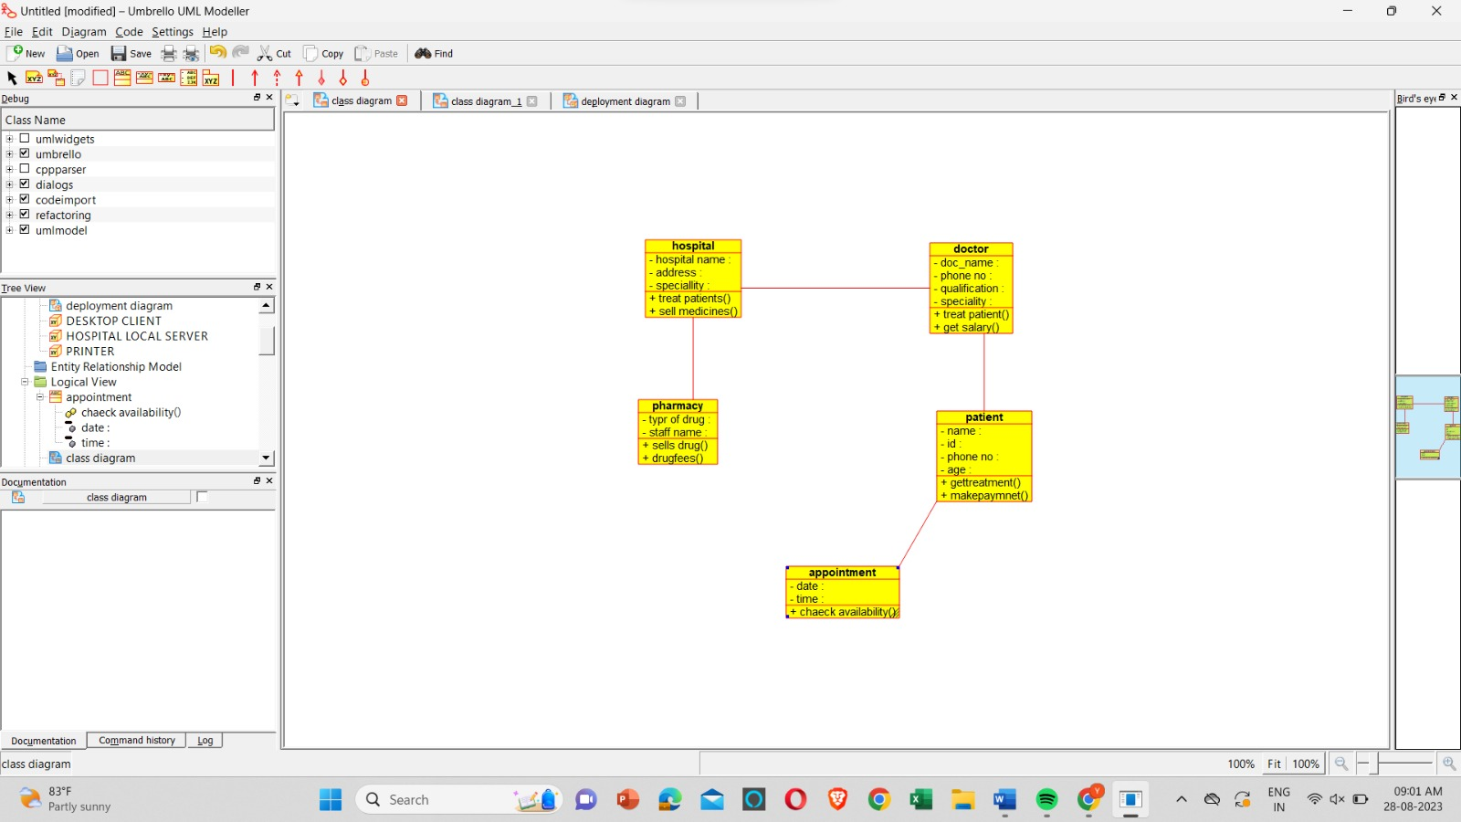

**PACKAGE :**

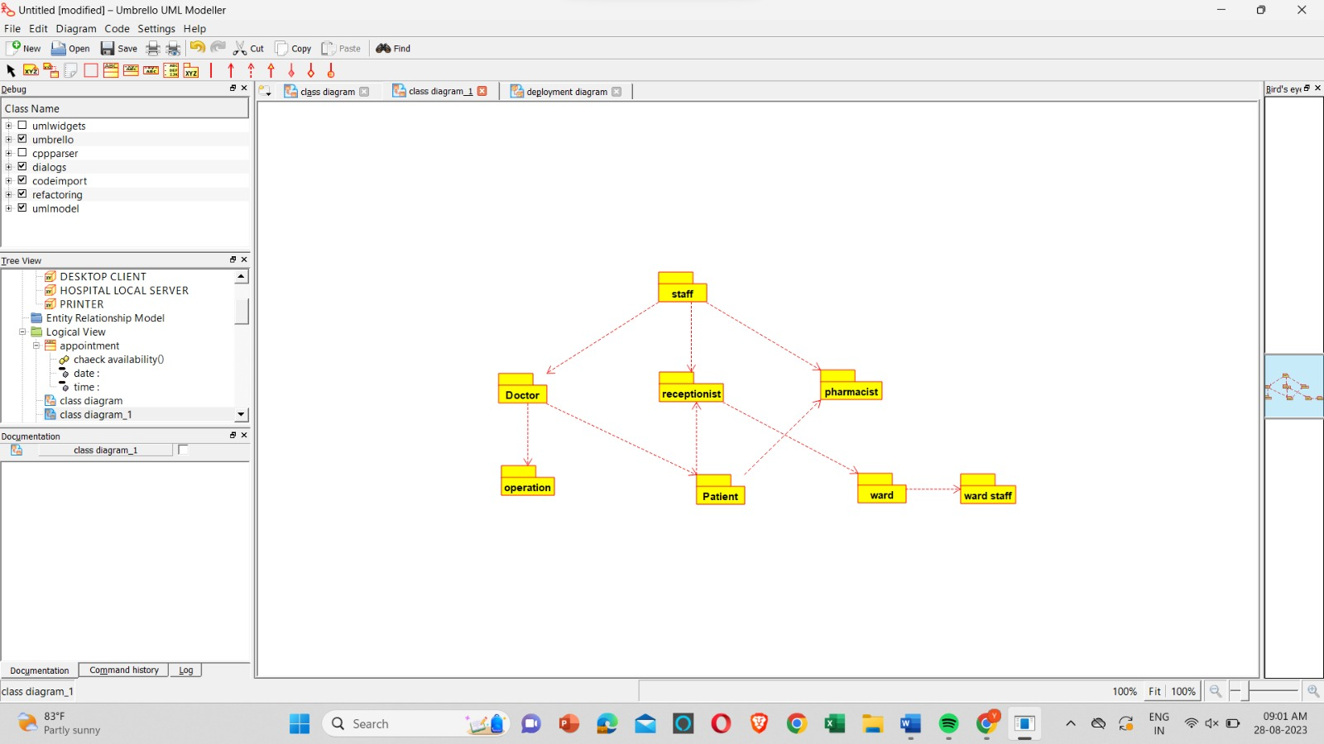

**DEPLOYMENT:**

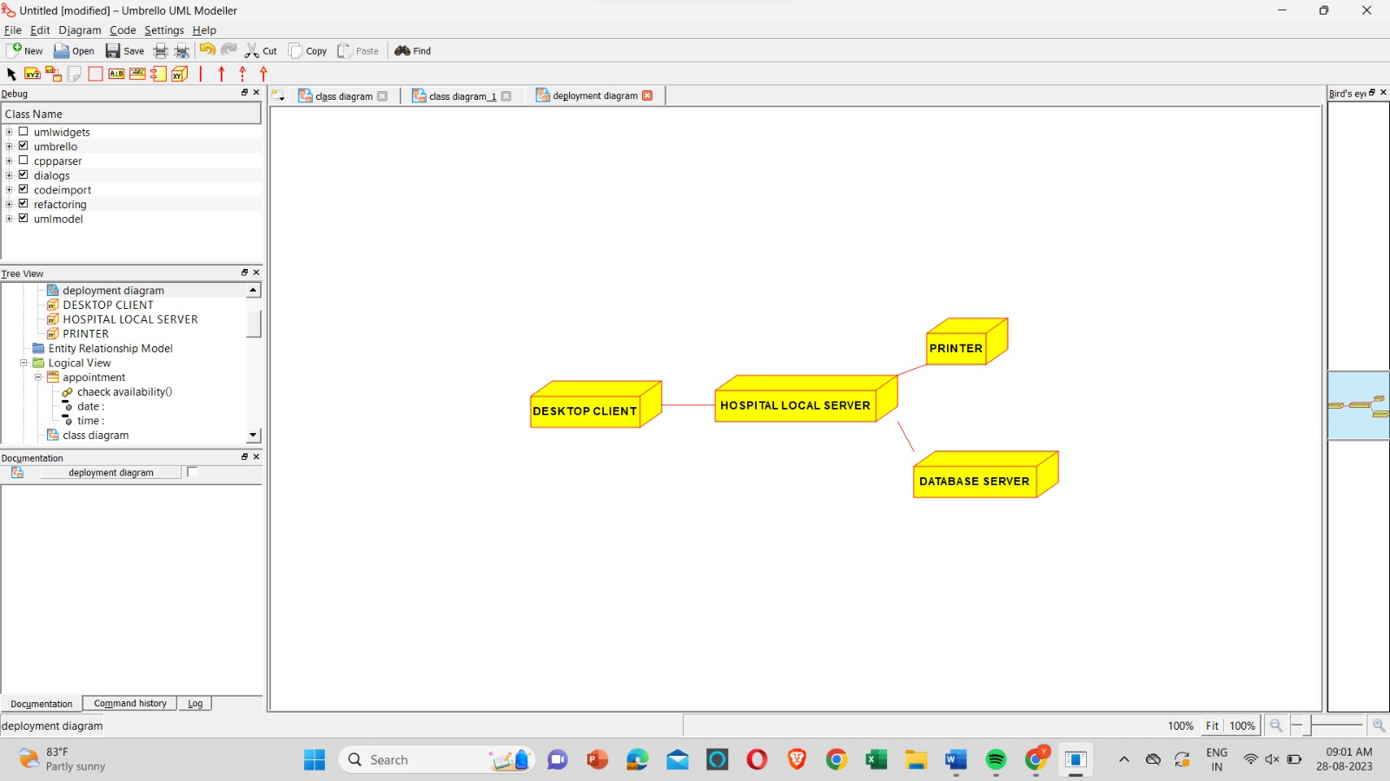

**RESULT** : Program was Executed Successfully using Umbrello**.**

**EXP 22:** **ONLINE INSURANCE SYSTEM**

**AIM :** To draw UML diagram for online insurance system using umbrello.

**ACTIVITY :**

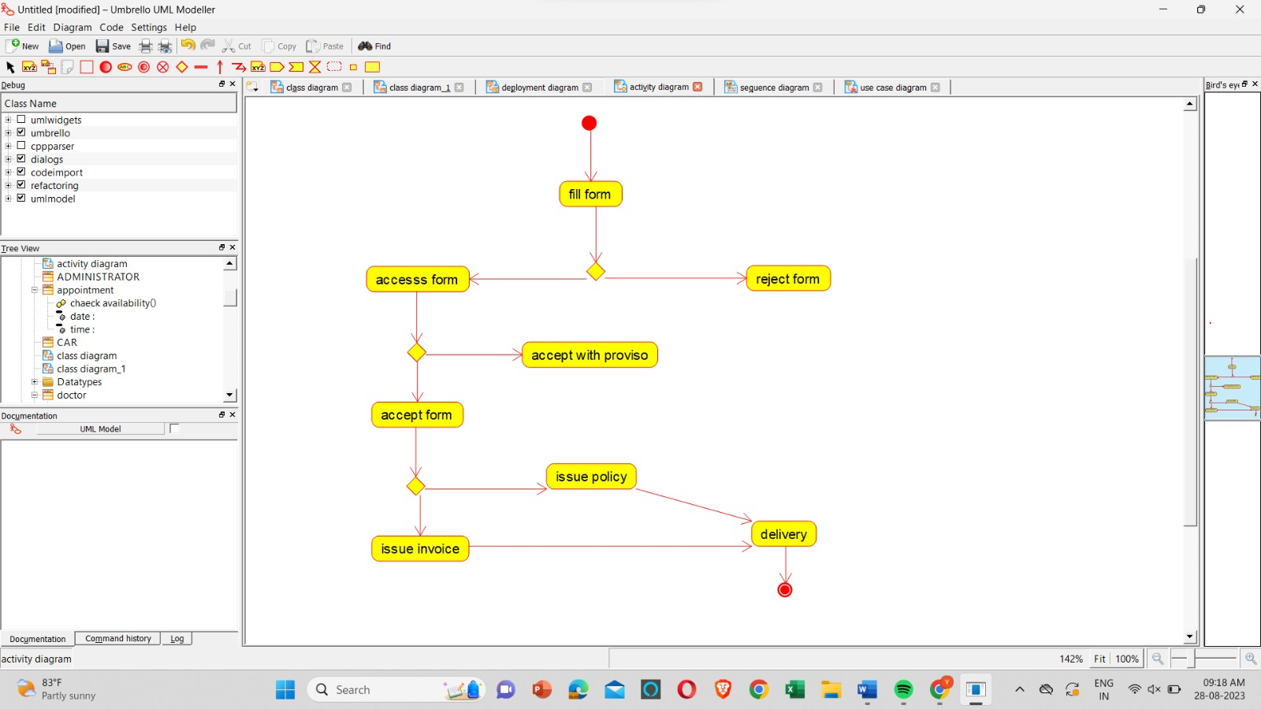

**SEQUENCE :**

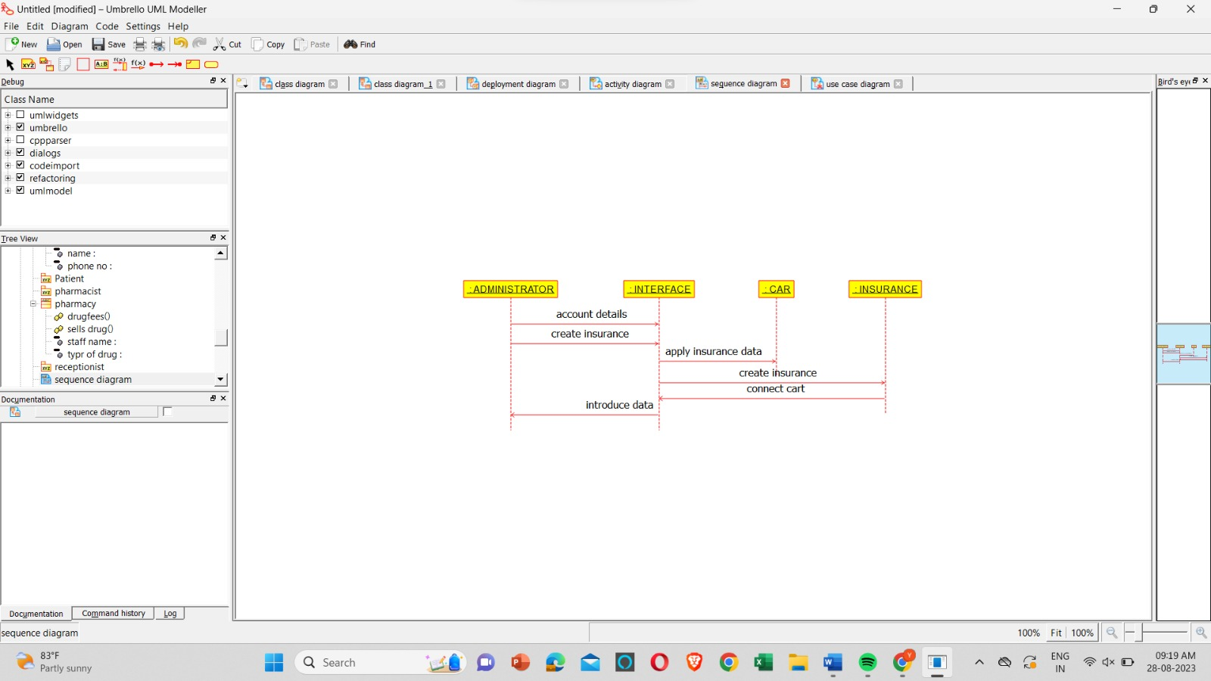

**USE CASE :**

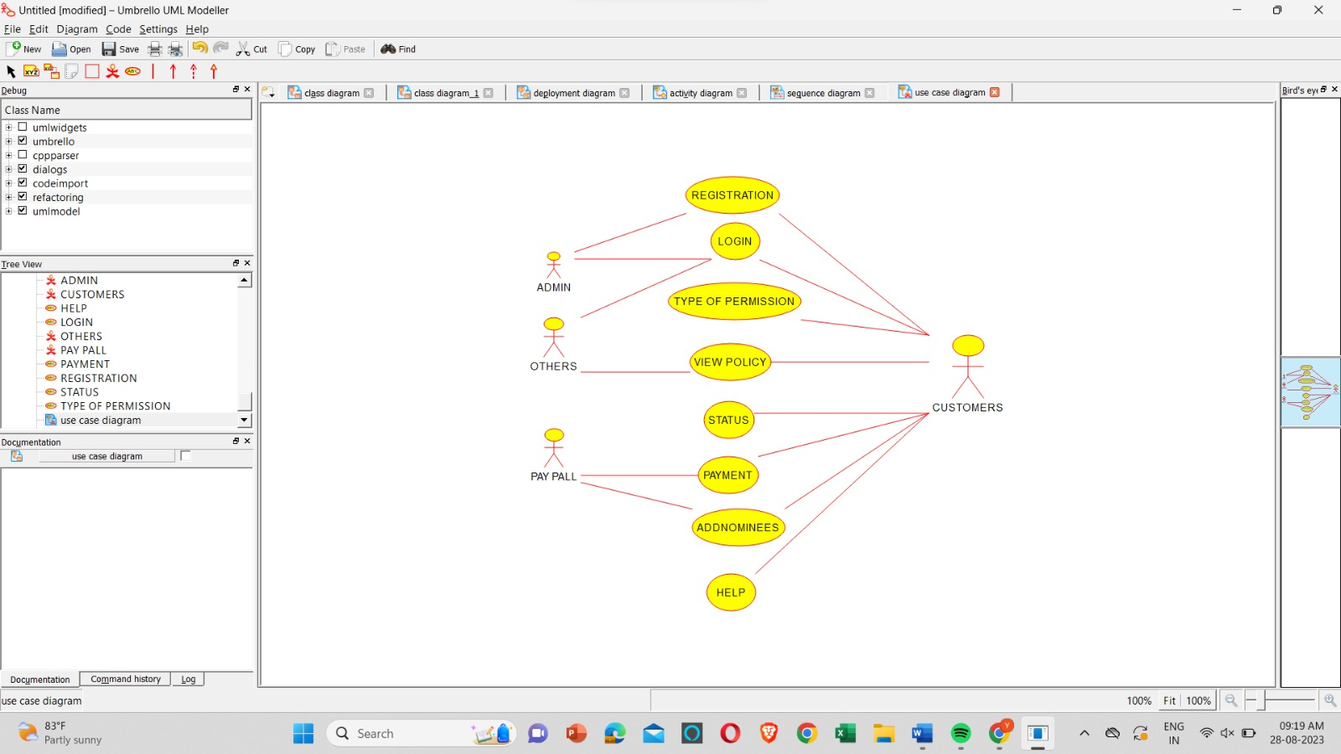

**RESULT** : Program was Executed Successfully using Umbrello**.**

**EXP 23 : ONLINE SHOPPING SYSTEM**

**AIM** : To draw the uml diagram for online shopping system using umbrello.

**COMPONENT:**

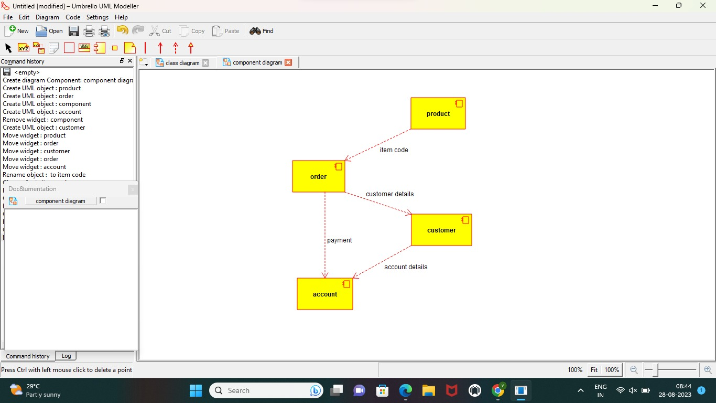

**USE CASE:**

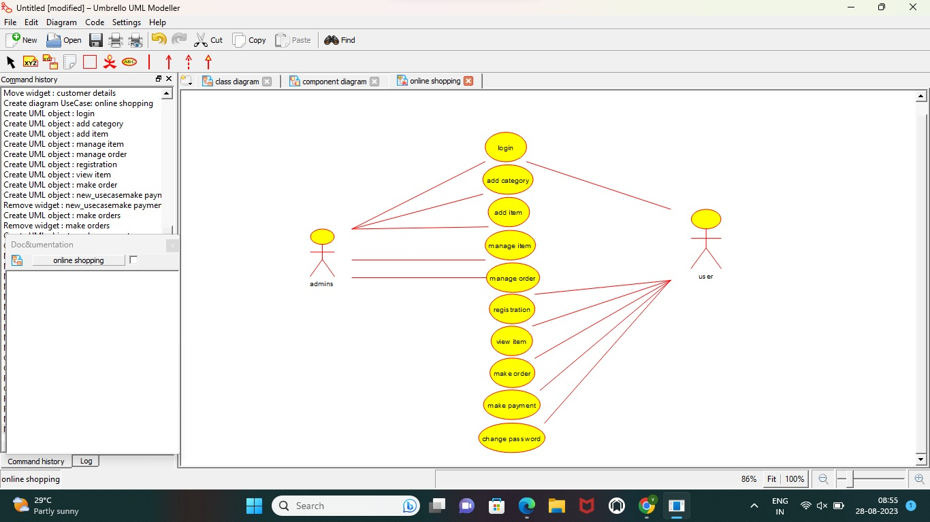

**ACTIVITY :**

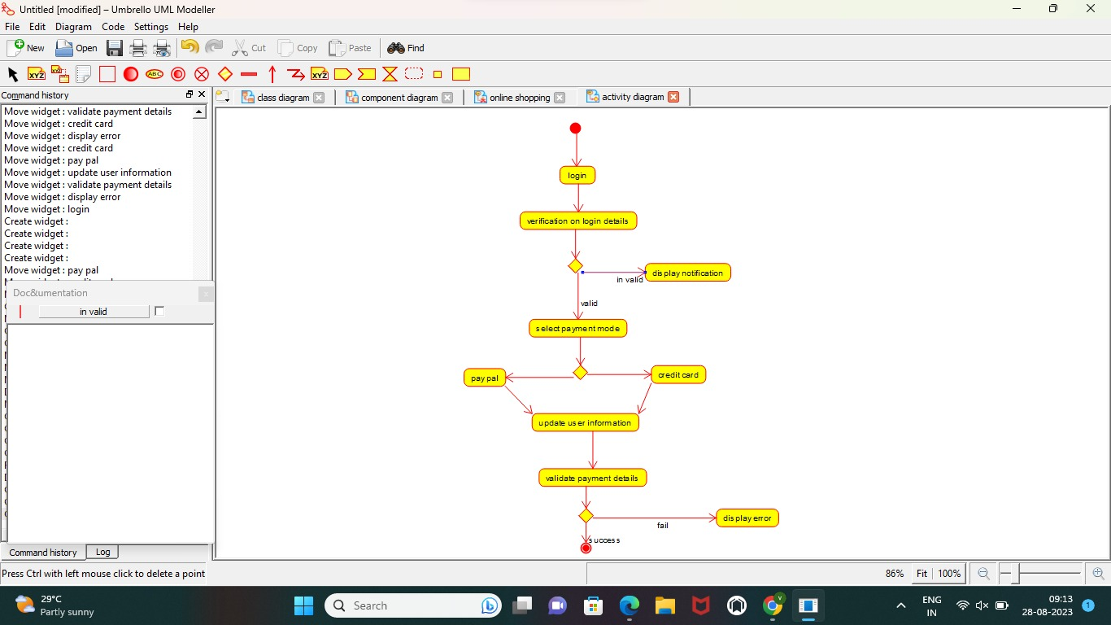

**RESULT** : Program was Executed Successfully using Umbrello**.**

**EXP 24: ONLINE STOCK MARKET**

**AIM :**  To draw the uml diagram for online stock market using umbrello.

**SEQUENCE:**

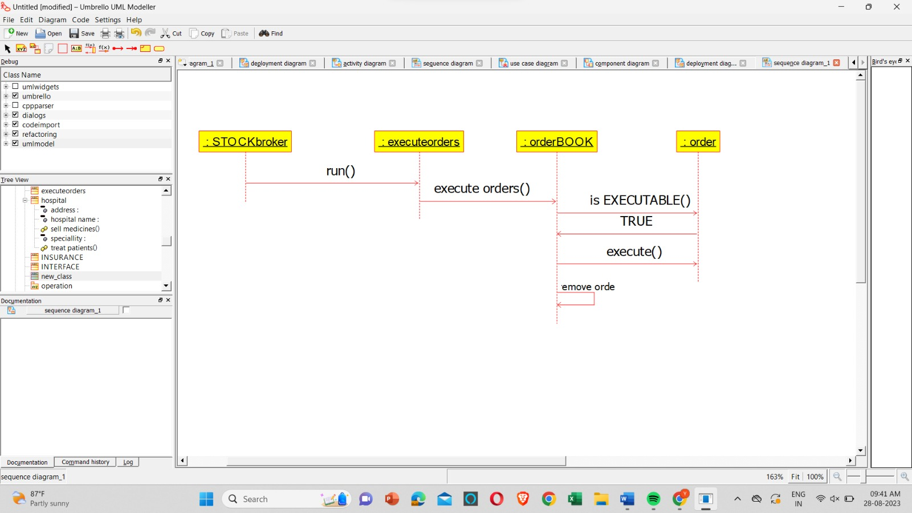

**DEPLOYMENT:**

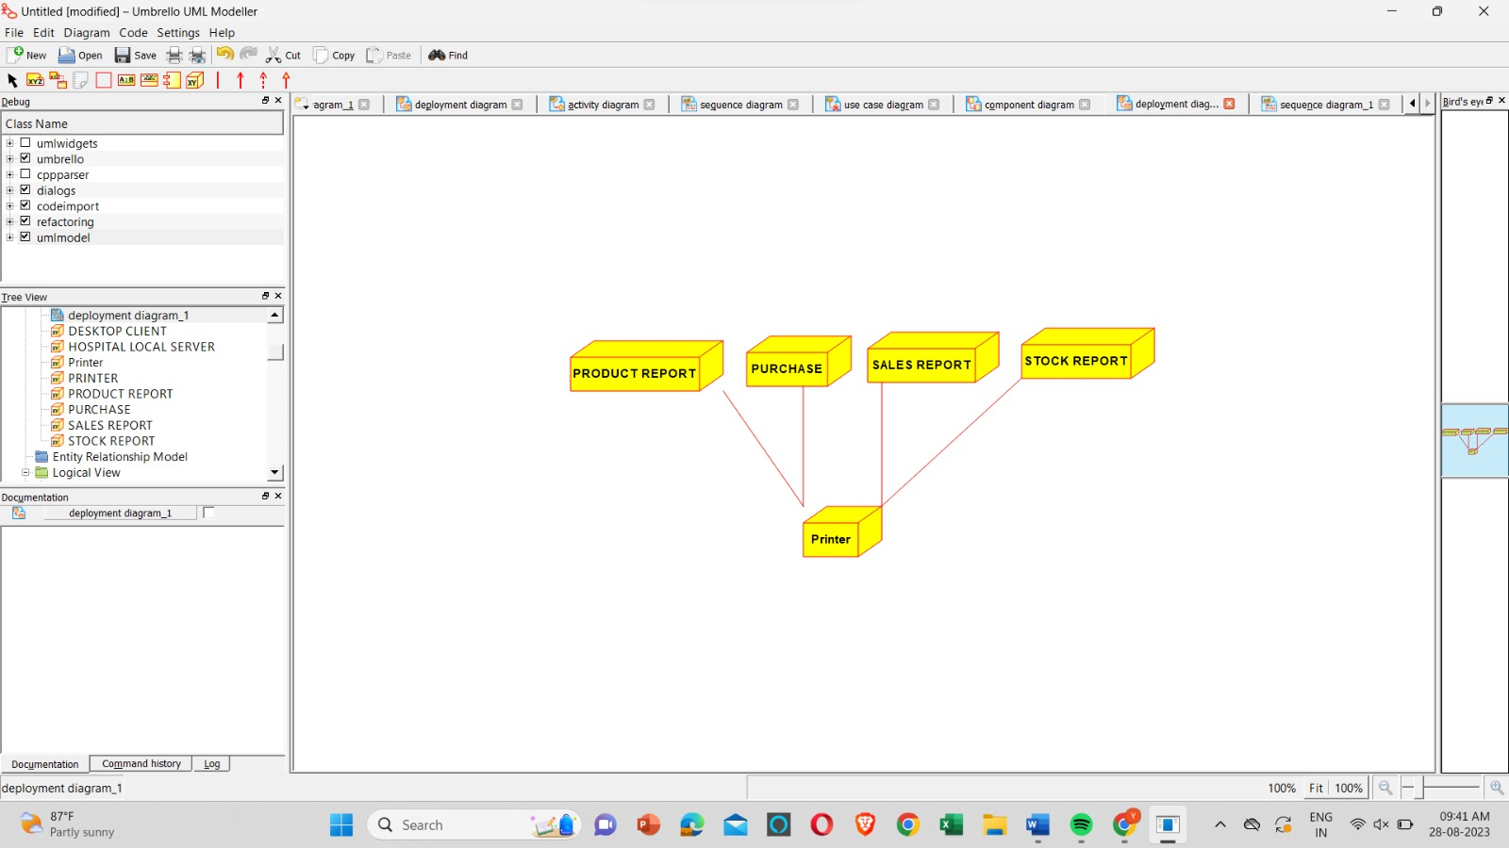

**COMPONENT :**

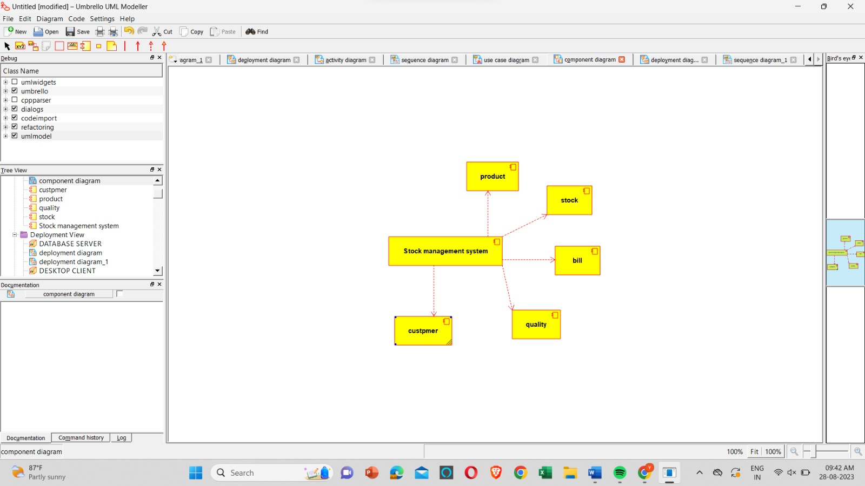

**RESULT** : Program was Executed Successfully using Umbrello**.**

**EXP 25 : ONLINE VOTING SYSTEM**

**AIM : :**  To draw the uml diagram for online voting system using umbrello.

**ACTIVITY:**

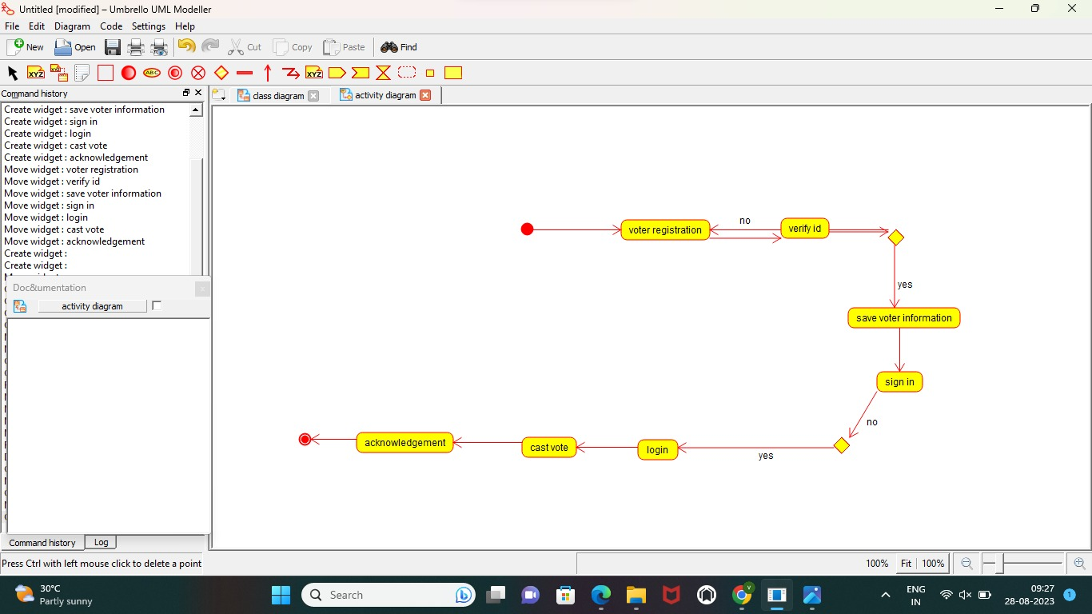

**COMPONENT :**

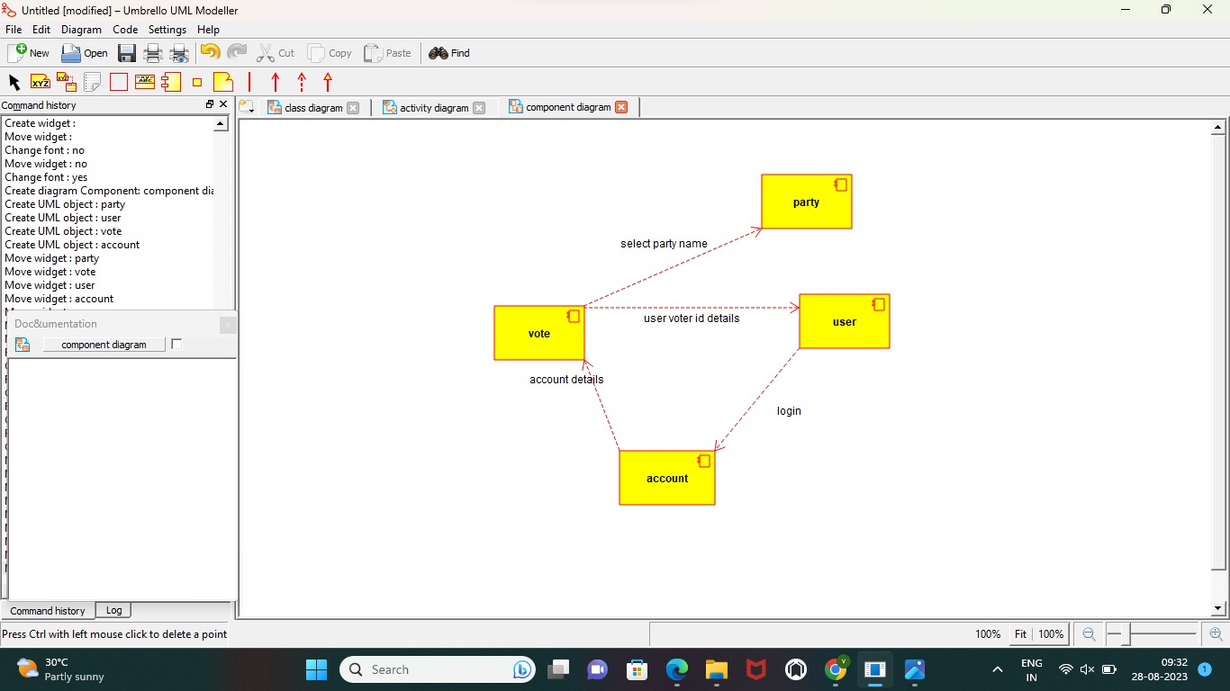

**CLASS DIAGRAM :**

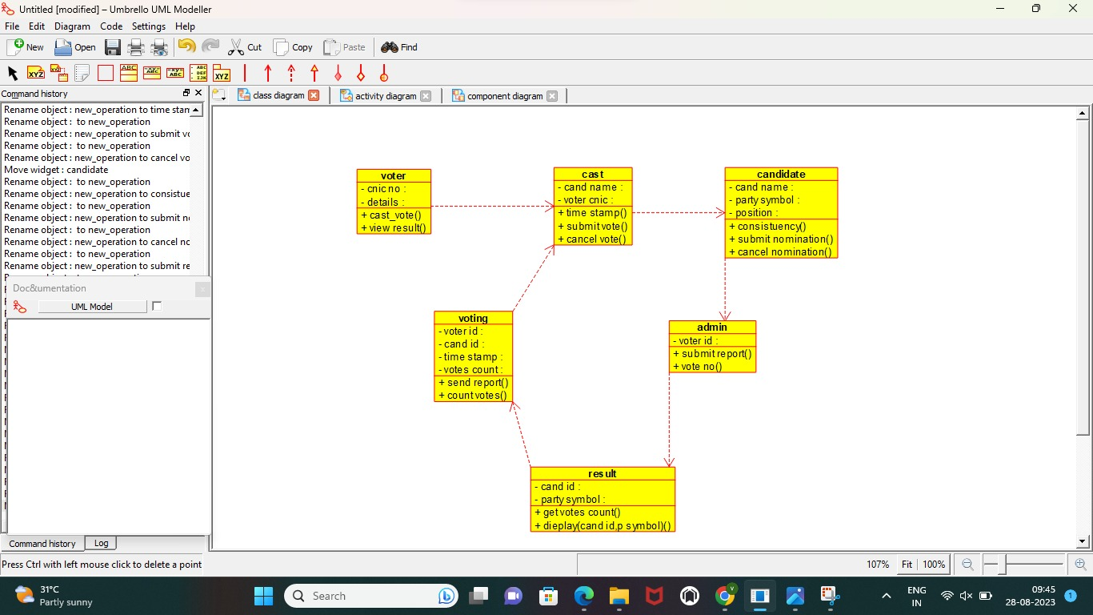

**RESULT** : Program was Executed Successfully using Umbrello**.**

**EXP 26 : JEWELLERY SHOP MANAGMENT**

**AIM :** To draw the UML diagrams for jewellery shop management system using umbrello.

**ACTIVITY:**

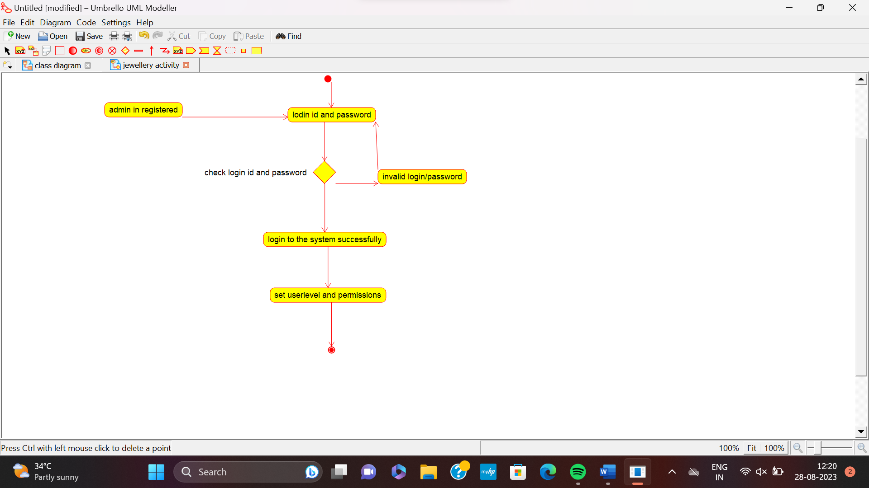

**SEQUENCIAL DIAGRAM:**

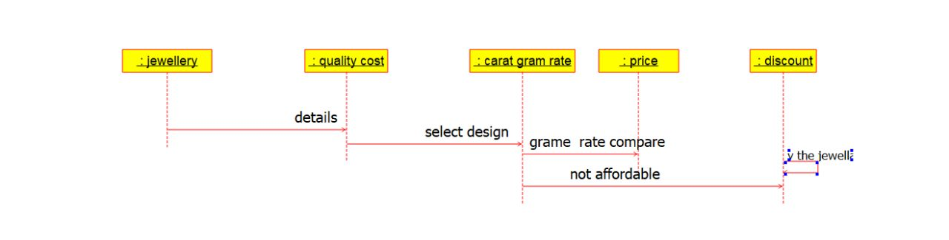

**COMPONENT :**

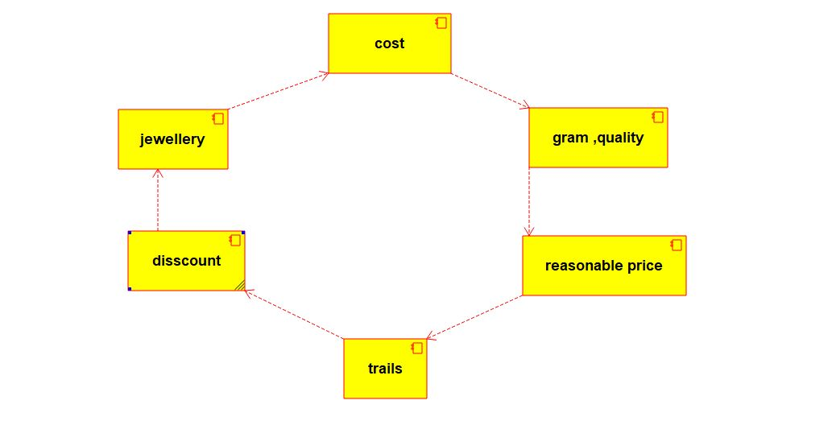

**RESULT :** Program was Executed Successfully using Umbrello.

**EXP 27:SUPERMARKET MANAGEMENT SYSTEM**

**AIM :** To draw the UML diagrams for supermarket management system using umbrello.

**USE CASE**

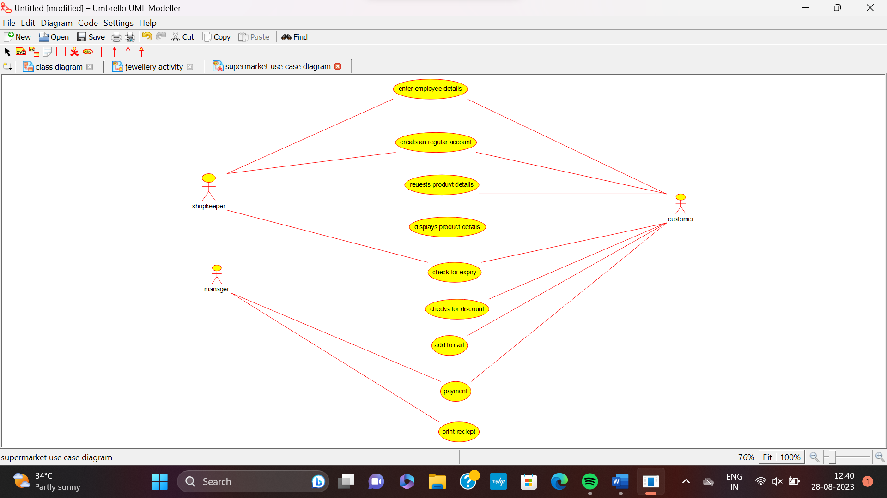

**ACTIVITY**

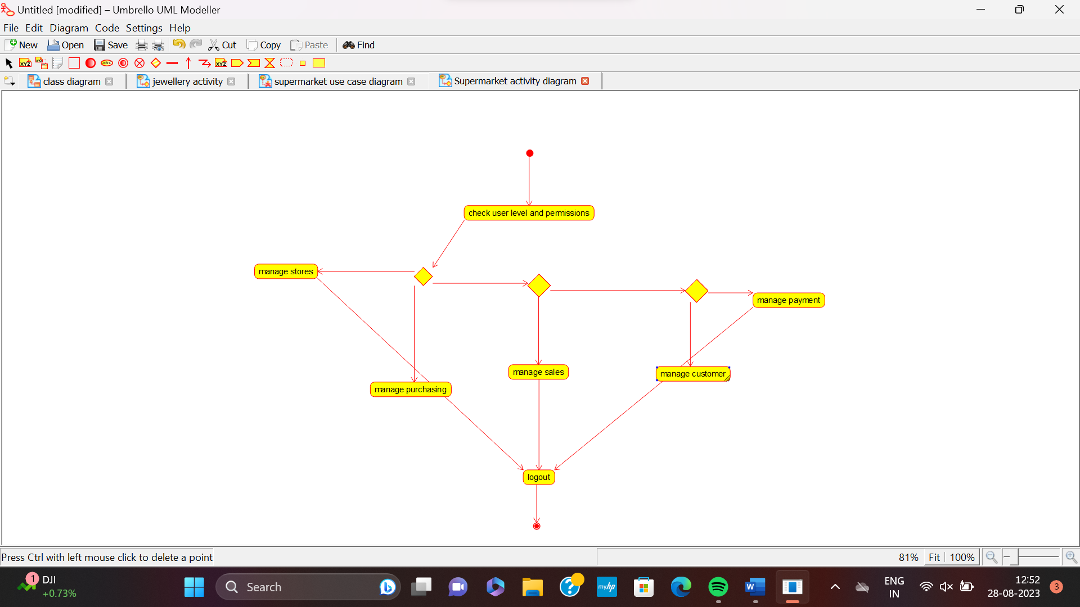

**SEQUENCE**

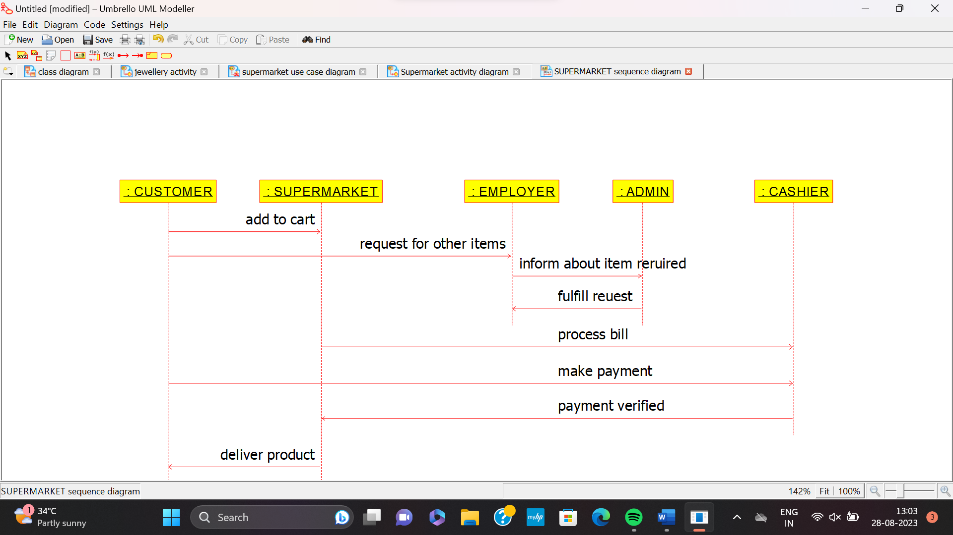

**RESULT:** Program was Executed Successfully using Umbrello.

**EXP 28:AIRPLANE RESERVATION SYSTEM**

**AIM:** To draw the UML diagrams for airline reservation system using umbrello.

**USECASE**

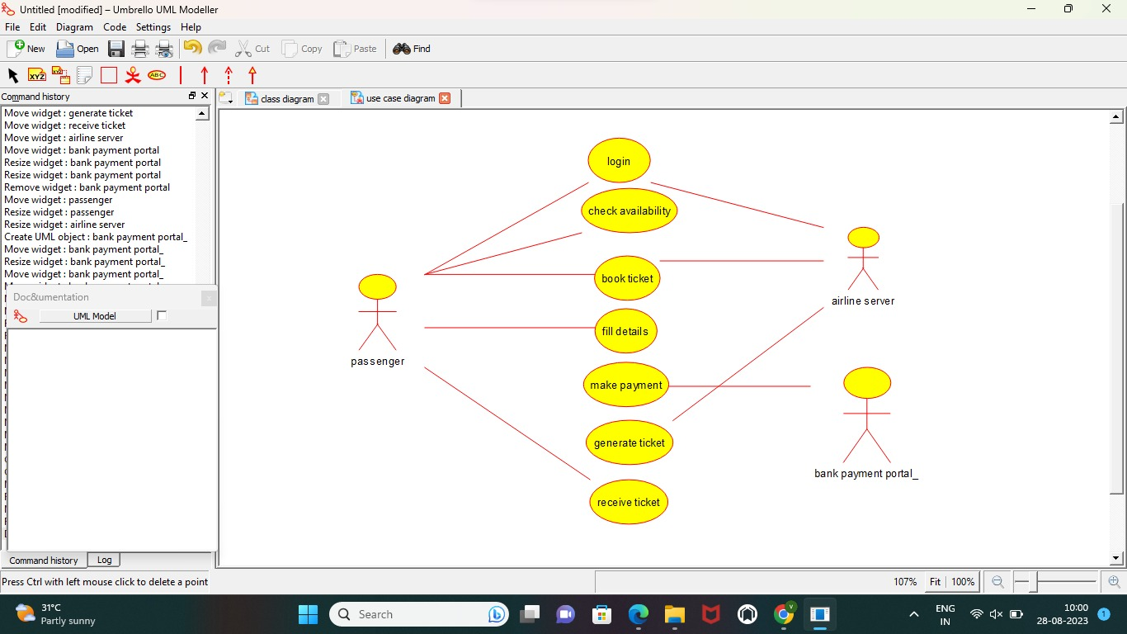

**SEQUENCE**

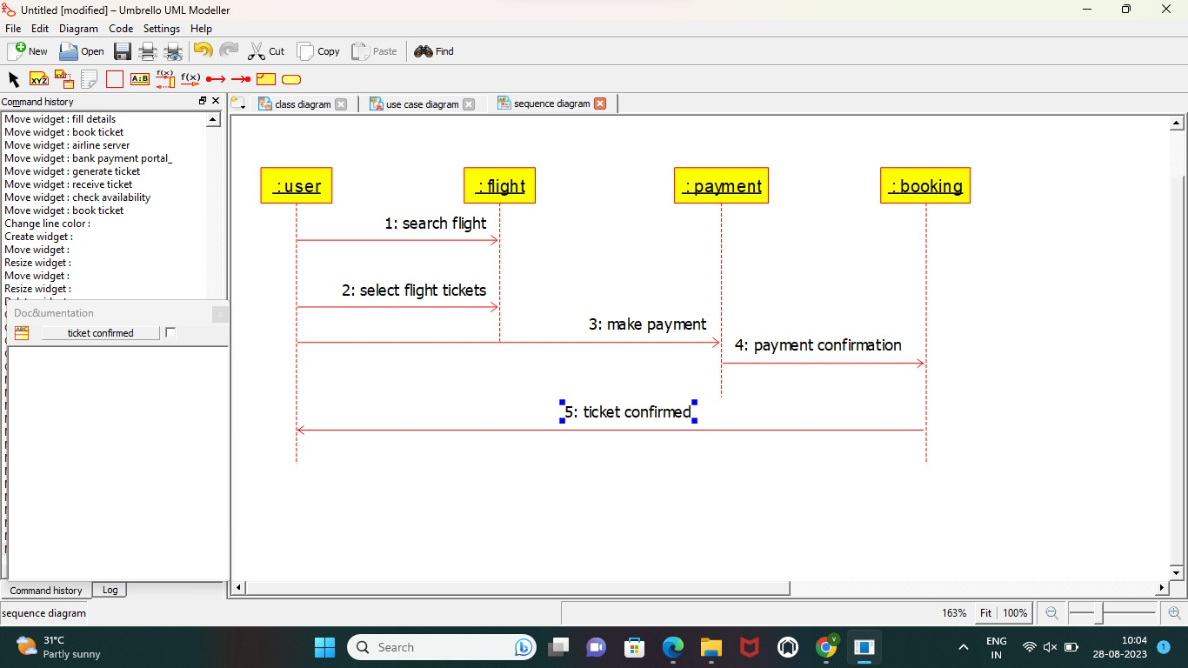

**COMPONENT**

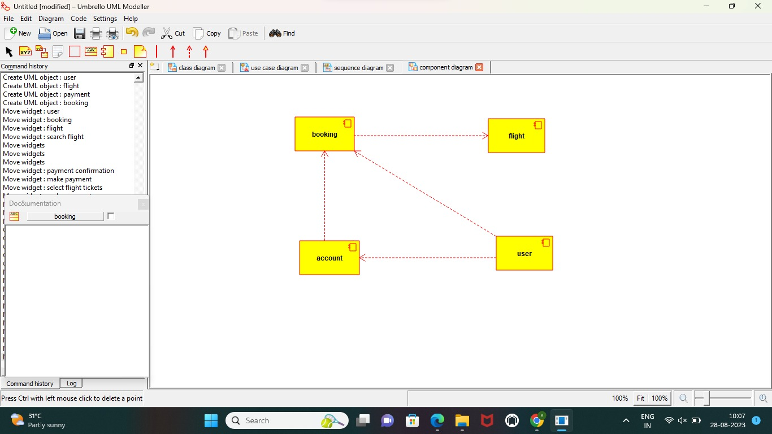

**RESULT:** Program was Executed Successfully using Umbrello.

**EXP 29:BUS RESERVATION SYSTEM**

**AIM:** To draw the UML diagrams for bus reservation system using umbrello.

**USECASE**

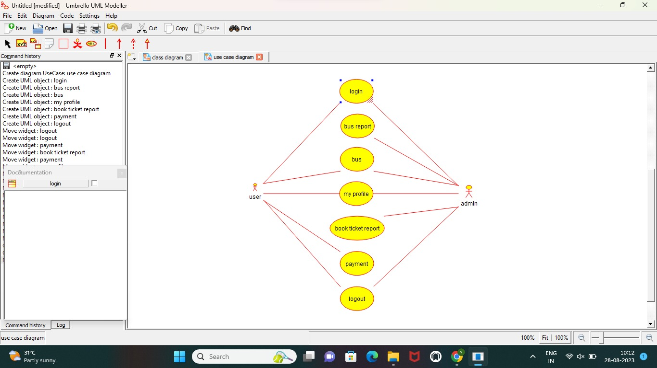

**SEQUENCE**

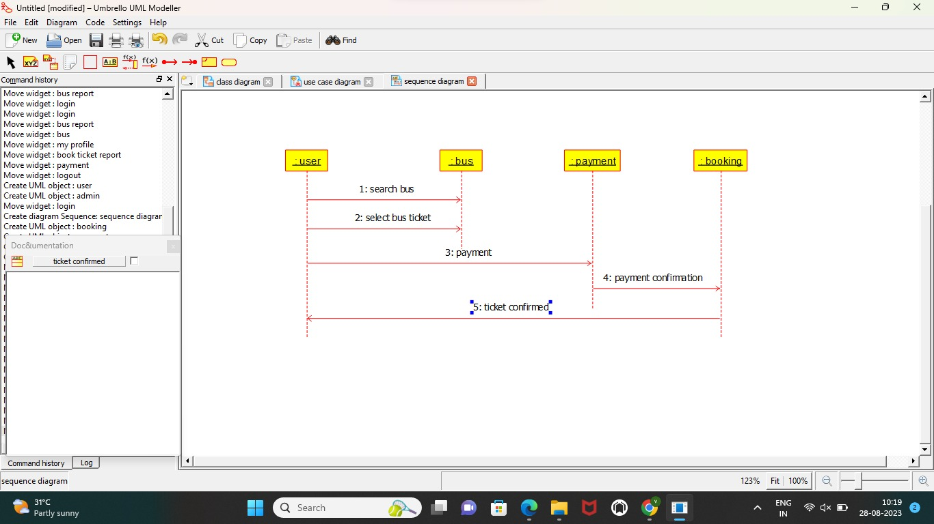

**COLLABRATION**



**RESULT:** Program was Executed Successfully using Umbrello.

**EXP 30:TRAIN TICKET RESERVATION SYSTEM**

**AIM:** To draw the UML diagrams for train ticket reservation system using umbrello.

**CLASS DIAGRAM**

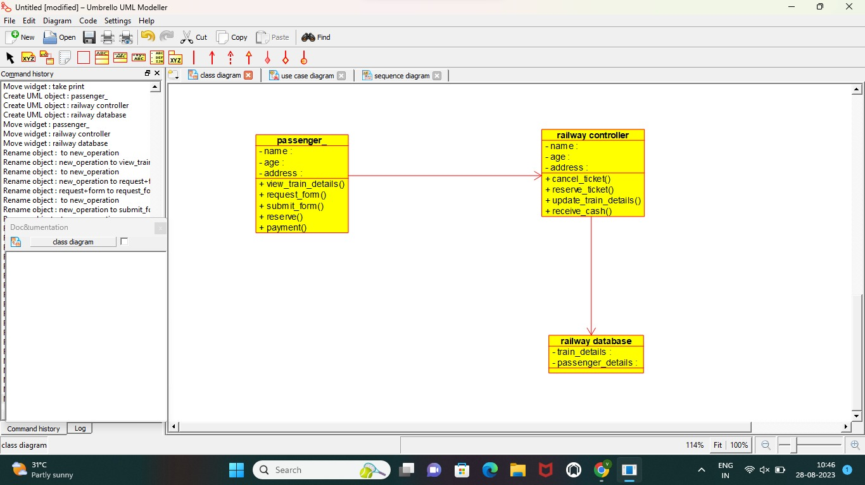

**SEQUENCE**

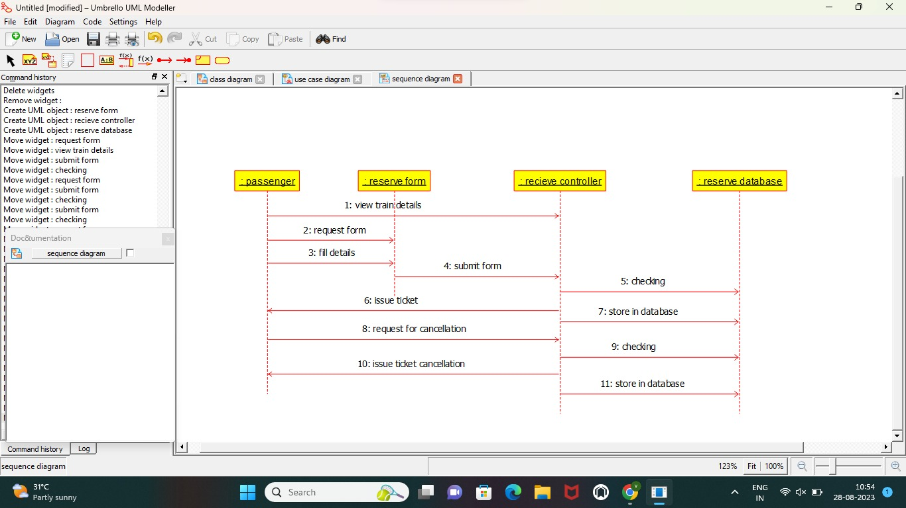

**COLLABRATION**

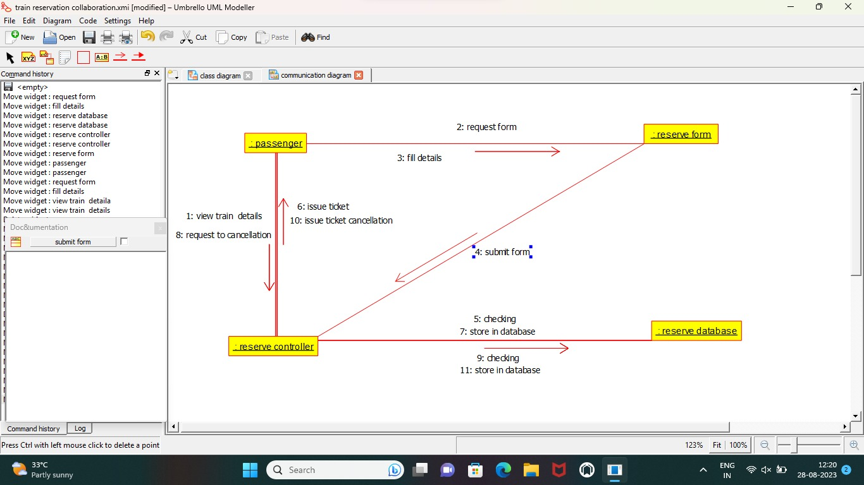

**RESULT:** Program was Executed Successfully using Umbrello.